C/C++ PI COMPUTATION LAB REPORT

1) Enter your name, student ID, platform (Mac or PC) and date
Name and StudentID: Jay Gupta, StudentID: 0961979
Class: CIS054 C/C++ Programming
Platform (Mac or PC): PC
Date: 2/22/2020

OBJECTIVES:
Use a while loop to compute an approximate value of pi using 'n' terms of an infinite series.

PROJECT DESCRIPTION:
An approximate value of pi can be calculated using the series given below:
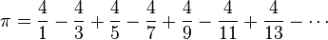
Write a C or C++ program that uses the successive approximation to compute pi. The program reads the number of terms for the calculation. Each term represents one of the fractions used in the computation. When pi has been computed, display the computed value of pi to 10 decimal places, the expected value, and the difference between the two values.
INPUTS | PROCESSING | OUTPUTS
Number of terms | Compute PI | Computed PI  PI Constant Value  Difference of the above two

LAB REPORT:
2) Fill in the TEST VALUES & ACTUAL RESULTS TABLE
RUN | TERMS | M_PI Constant | ACTUAL RESULT  Fill in the output displayed by the program | DIFFERENCE  Between the actual result and the M_PI constant
1 | 10 | 3.14159265358979 | Computed PI = 3.0418396189 | Difference = 0.0997530347
2 | 100 | 3.14159265358979 | Computed PI = 3.1315929036 | Difference = 0.0099997500
3 | 1,000 | 3.14159265358979 | Computed PI = 3.1405926538 | Difference = 0.0009999997
4 | 10,000 | 3.14159265358979 | Computed PI = 3.1414926536 | Difference = 0.0001000000
5 | 100,000 | 3.14159265358979 | Computed PI = 3.1415826536 | Difference = 0.0000100000
NOTE: You cannot use a comma when entering numbers with cin or scanf.

DISCUSSION:
3) Complete the DISCUSSION section. It does not need to be long, but it needs to be complete.
3a) What did you do to develop the program? ("Followed the Directions" is not a complete description

First, I defined the variables that seemed the most obvious: the numerator and denominator, the pi that would be calculated, terms and the loop count. Then, I created the input section, and after, the processing. I didn’t want to view the solution you had posted; I wanted to see if I could figure out the pattern and translate it into code logic. After I did that, I worked on output, calculating the difference and setting the decimal places to 10. After that, I tested out a variety of numbers, to make sure it worked.

Although the project description didn’t ask for input validation, I added it anyways, since I believe it is a large part of programming: you don’t want incorrect values inputted into the program, because it makes for unexpected results.

3b) What problems did you have and how did you overcome the problems?

While creating the processing, I ran into a few moments where I ran a continuous loop, and it was because I didn’t increment the ‘loopCount’ variable, or I forgot it entirely. To overcome this, I read my program carefully, and made sure to test for the values stated in this lab report, as well as others.

PROGRAM OUTPUT:
4) Show five screen shots of the program. One for each of the runs (terms = 10, 100, 1000, 10000, 100000)
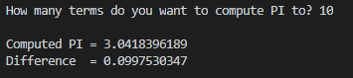

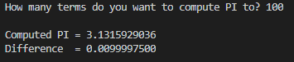

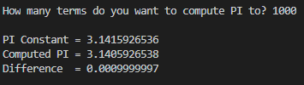

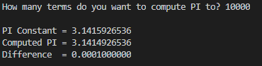

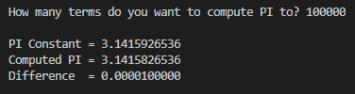
IMPORTANT: Capture only the portion of the screen that shows the program output. Do not capture the entire screen even though it may also contain the program output. Many times when I zoom in on the output window, the image resolution is so poor that I am not able to read your output. If this happens, I will ask that you resubmit your lab report.

For the Mac, hold down command + shift keys and press the 4 key to get a screenshot of a selected area of the screen. Use the mouse or touchpad to select the desired area.
Use command+V to paste the clipboard into the lab report.

For Windows, There are two ways you can capture a screen shot of only your program:
- Use Microsoft's Snipping Tool by clicking on the Start icon and selecting "All Programs" then "Accessories". Use the mouse to select the area of the screen you want to save then click Ctrl-C or select the menu items Edit-Copy to save the image to the clipboard.
- Capture the active window to the clipboard by holding down the Alt key and tapping the PrintScreen key. NOTE: some notebook computers require that you hold down a [Fn] key and Alt keys to activate the PrintScreen function. NOTE: Do not click PrintScreen without the Alt key. This would capture the entire screen which would make your program output difficult to see.
Use Ctrl+V to paste the clipboard into the lab report.
Sample program output for 500 terms
How many terms do you want to compute pi? 500
Computed pi = 3.1395926556
Expected value = 3.1415926536
Difference = 0.0019999980

PROGRAM LISTING:
5) Copy and paste the code that YOU typed to make the program work. Your program should include a comment block at the top that shows the name of the program, date, version and your name.
/*
Name: Jay Gupta
Student ID: 0961979
Date: 2/22/2020
Program Name: C++_Computation_of_PI.cpp (V1.0)
CIS054 C/C++ Programming

Input: Number of terms
Output: Computed PI, PI Constant value, Difference between the two
*/

#include <iostream> // cin and cout
#include <iomanip> // to set decimal places
#include <cmath> /// math functions, constants (PI)
using namespace std;

const double PI_VALUE = 3.14159265358979;

int main() {
// variables (for input)
int terms;

// variables (for processing)
int loopCount = 1;
double pi = 0;

double numerator = 4;
double denominator = 1;
double fraction;

double difference;

// input: how many terms does the user want?
cout << endl << "How many terms do you want to compute PI to? ";
cin >> terms;

if (terms < 0) {
cout << "The number of terms can't be negative." << endl << endl;
return 1;
} else if (cin.fail()) {
cout << "Illegal entry for terms: enter an integer greater than or equal to 0." << endl << endl;
return 1;
}

// processing
while (loopCount <= terms) {
// compute term to be added
fraction = numerator / denominator;

if (loopCount % 2 == 1) {
pi += fraction;
} else {
// term number is even
pi -= fraction;
}
denominator += 2;
loopCount += 1;
}

difference = fabs(PI_VALUE - pi);

cout << endl; // blank line before output

cout << fixed << setprecision(10);
cout << "PI Constant = " << PI_VALUE << endl;
cout << "Computed PI = " << pi << endl;
cout << "Difference = " << difference << endl << endl;

return 0;
}

